Take Assessment - EWAN Chapter 2 - CCNA Exploration (Version 4.0)

1 | Principio del formulario
  Which three statements are correct about HDLC encapsulation? (Choose three.)
   | HDLC does not support CDP.
   | HDLC and PPP are compatible.
   | HDLC supports PAP and CHAP authentication.
   | HDLC implementation in Cisco routers is proprietary.
   | HDLC is the default serial interface encapsulation on Cisco routers.
   | HDLC uses frame delimiters to mark the beginnings and ends of frames.
2 | Principio del formulario
  What advantage does PPP have over HDLC for serial communications?
   | It can communicate more efficiently with other Cisco devices
   | It is less complex to configure
   | It has less Layer 2 overhead
   | It supports authentication

3 | Principio del formulario
  Which two statements are true about time-division multiplexing (TDM)? (Choose two.)
  TDM relies on Layer 3 protocols to operate.
  Multiple sources can transmit over a single channel.
  Original data streams must be reconstructed at the destination.
  TDM methods vary depending on the Layer 2 protocol that is used.
  It allows information from multiple channels to be allocated bandwidth on multiple wires.
4 | Principio del formulario
  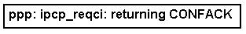
  Refer to the exhibit. Which two statements are true regarding the output shown? (Choose two.)
  The router has agreed on IP parameters.
  The router has negotiated LCP successfully.
  The router is negotiating IP compression options.
  The router is requesting an IP address from its peer.
  The router has accepted IP but not the suggested IP options.

5 | Principio del formulario
  Which three statements correctly describe PPP authentication? (Choose three.)
  PAP sends passwords in clear text.
  PAP uses a 3-way handshake to establish a link.
  PAP provides protection from repeated trial-and-error attacks.
  CHAP uses a 2-way handshake to establish a link.
  CHAP uses a challenge/response that is based on the MD5 hash algorithm.
  CHAP uses repeated challenges for verification.
6 | Principio del formulario
  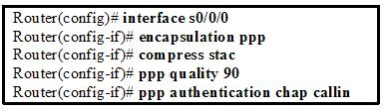
  Refer to the exhibit. What can be concluded about the function of the Serial 0/0/0 interface on the router after the commands are entered?
  All username and password information that is sent will be encrypted.
  All authentication on the serial link will be accomplished using a three-way handshake.
  The Predictor algorithm will be used to compress all packets that are sent and received on the serial link.
  The serial link will be closed if the number of received packets at the destination node falls below 90 percent of the packets that are sent.

7 | Principio del formulario
  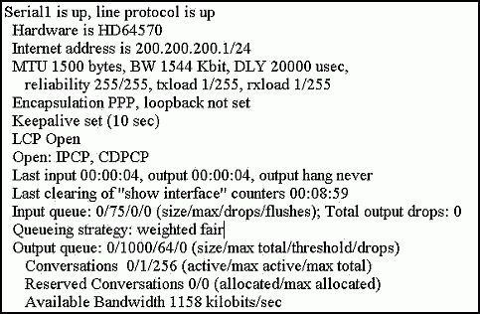
  Refer to the exhibit. Which statement is true about PPP operation?
  Layer 2 is down.
  LCP, IPCP, and CDPCP negotiations are in progress.
  Only the link-establishment phase completed successfully.
  Both the link-establishment and network-layer phase completed successfully.
8 | Principio del formulario
  Which PPP configuration option can be used to establish load balancing over the interfaces of a router?
  callback
  multilink
  compression
  error detection

9 | Principio del formulario
  Which two options can LCP negotiate? (Choose two.)
  link quality
  authentication
  dynamic flow control
  compression and network layer address for IP
  connection-oriented or connectionless communication methods
10 | Principio del formulario
  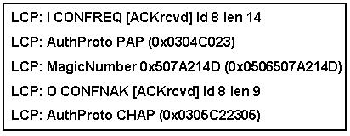
  Refer to the exhibit. What statement is true regarding the output shown?
  NCP has successfully negotiated.
  The PAP passwords did not match, so the routers are trying CHAP authentication.
  One router has suggested PAP authentication, and the other has accepted authentication but suggested CHAP authentication.
  One router can only use PAP authentication while the other router can only use CHAP, so the connection has been rejected.

11 | Principio del formulario
  Which authentication protocol can be spoofed to allow playback attacks?
  MD5
  CHAP
  PAP
  NCP
12 | Principio del formulario
  Why are serial connections preferred over parallel connections for long transmission lengths?
  Parallel connections do not support error checking.
  Parallel connections are subject to excessive attenuation.
  Parallel connections are subject to clock skew and to crosstalk between wires.
  Parallel connections transmit over only two wires and therefore transmit data more slowly.

13 | Principio del formulario
  Which three statements are true regarding LCP? (Choose three.)
  It is responsible for negotiating link establishment.
  It negotiates options for Layer 3 protocols running over PPP.
  It uses MD5 encryption while negotiating link establishment parameters.
  It terminates the link upon user request or the expiration of an inactivity timer.
  It can test the link to determine if link quality is sufficient to bring up the link.
  It monitors the link for congestion and dynamically adjusts the acceptable window size.
14 | Principio del formulario
  What does the demarcation point represent in data communication physical circuits?
  DTE/DCE interface on the device connecting to the Internet
  location of the firewall or router
  physical point at which the public network ends and the private customer network begins
  tag assigned to the physical block where a cross-connect occurs

15 | Principio del formulario
  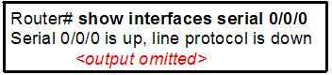
  Refer to the exhibit. While troubleshooting a serial interface, a technician enters the command show interface serial 0/0/0 . If the interface is in DCE mode, what two problems are likely to cause the indicated problem? (Choose two.)
  The remote CSU or DSU has failed.
  The router is not sensing a CD signal.
  A timing problem has occurred on the cable.
  The line is not physically connected to the CSU/DSU.
16 | Principio del formulario
  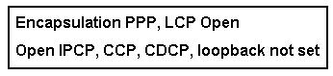
  Refer to the exhibit. What statement is true regarding the output shown?
  LCP is in the process of negotiating a link.
  LCP and NCP are waiting for CHAP authentication to complete.
  LCP negotiation has been successful, but NCP negotiation is in progress.
  Data is able to flow across this link.
17 | Principio del formulario
  What function do Network Control Protocols provide for a PPP connection?
  to supply error detection
  to establish and terminate data links
  to provide authentication capabilities to PPP
  to manage network congestion and to allow quality testing of the link
  to allow multiple Layer 3 protocols to operate over the same physical link

18 | Principio del formulario
  Which serial communications DTE/DCE interface standard is used to provide high-speed connectivity of up to 52 Mbps between LANs and is found on many high-end Cisco routers?
  EIA/TIA 232 (RS-232)
  EIA/TIA 422 (RS-422)
  EIA/TIA 423 (RS-423)
  EIA/TIA-612/613 (HSSI)
  ITU V.35
19 | Principio del formulario
  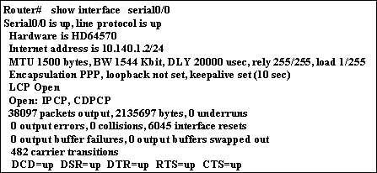
  Refer to the exhibit. On the basis of the show interface Serial0/0 output, how many NCP sessions have been established?
  one
  two
  three
  four

20 | Principio del formulario
  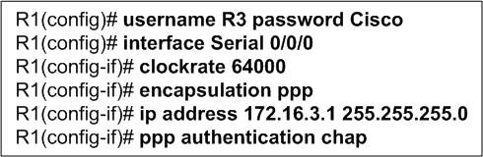
  Refer to the exhibit. Router R1, the DCE device, has just been configured for PPP encapsulation with authentication. What series of commands will allow another router, the DTE device, to communicate over its serial 0/0/0 interface to router R1?
  Router(config)# hostname R3
  R3(config)# username R1 password Cisco
  R3(config)# interface Serial 0/0/0
  R3(config-if)# encapsulation ppp
  R3(config-if)# ip address 172.16.3.3 255.255.255.0
  R3(config-if)# ppp authentication chap
  Router(config)# hostname R3
  R3(config)# username R3 password Cisco
  R3(config)# interface Serial 0/0/0
  R3(config-if)# encapsulation ppp
  R3(config-if)# ip address 172.16.3.3 255.255.255.0
  R3(config-if)# ppp authentication chap
  Router (config)# username Router password Cisco
  Router (config)# interface Serial 0/0/0
  Router (config-if)# clockrate 64000
  Router (config-if)# encapsulation ppp
  Router (config-if)# ip address 172.16.3.1 255.255.255.0
  Router config-if)# ppp authentication chap
  Router (config)# username R1 password Cisco
  Router config)# interface Serial 0/0/0
  Router (config-if)# clockrate 64000
  Router config-if)# encapsulation ppp
  Router (config-if)# ip address 172.16.3.1 255.255.255.0
  Router (config-if)# ppp authentication chap
21 | Principio del formulario
  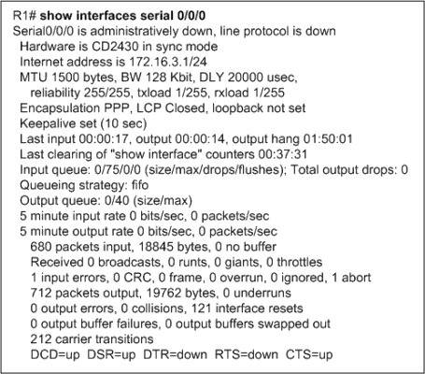
  Refer to the exhibit. Router R1 is not able to communicate with a neighbor router that is directly connected to serial 0/0/0. What is the reason for this?
  Interface Serial0/0/0 resets very frequently.
  PPP LQM has shutdown the serial interface.
  The serial interface has no input or output queues available.
  The serial interface is not configured for a Layer 2 protocol.
  The interface has been administratively shutdown with the shutdown command.

